**Coding Convention**

**1/ C# Best Practices**

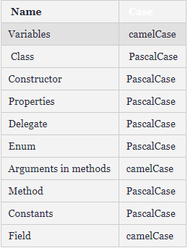

Const variable: ALL_UPPER_CASE

Use prefix I for Interface: IAuthRepository

Use “Is”, “Has”, “Can” for Boolean values: “IsVisible”, “HasChildren”, “CanExecute”

Always use Properties instead of public variables:

~~NO: public string name;~~

YES: public string Name { get; set; }

**2/ Typescript Best Practices**

Use Prettier

Namespaces, function, function parameters, methods, fields are camelCased

myFunction(), myMethod(), myField

Class, enums and enum members are TitleCased

MyClass, MyEnum, MyEnumMember

Use string, number instead of ~~String, Number~~  (primitive vs non-primitive)